DS Practicals

Sem 3

Batch 31

Name: Anik Shaikh

Enrollment no. – 23162121021

Q-1 Gross Salary Problem

In a company an employee is paid as under:

Along with the basic salary, the employee would be given dearness allowance of 40% of his

basic salary and house rent allowance of 20% of his basic salary. If the basic salary of an

employee is received as input, write a program to find his/her gross salary.

Code:

#include <stdio.h>

void main() {

int x;

printf("Enter your basic salary: ");

scanf("%d",&x);

float y = x\*0.4 + x\*0.2 + x;

printf("Your gross salary is: %f", y);

}

Screenshot:

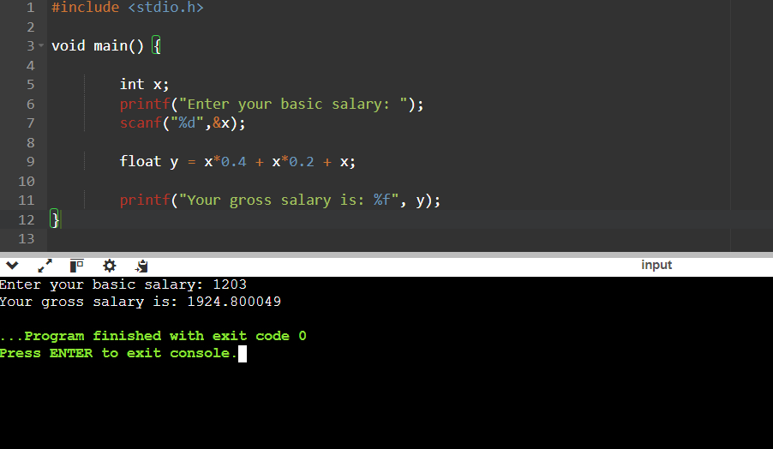

Q-2 Conversion Problem

The distance between two cities (in km.) would be given by the user. Write a program to convert

and print this distance in:

1. Feet.

2. Meters.

3. Inches.

4. Centimeters.

Code:

#include <stdio.h>

void main() {

float x;

printf("Enter your distance in km: ");

scanf("%f",&x);

float feet = x\*3280.84;

float inch = x\*39370.08;

float m = x\*1000;

float cm = x\*100000;

printf("Your distance in feet is: %f\n", feet);

printf("Your distance in inch is: %f\n", inch);

printf("Your distance in meters is: %f\n", m);

printf("Your distance in centimeters is: %f\n", cm);

}

Screenshot:

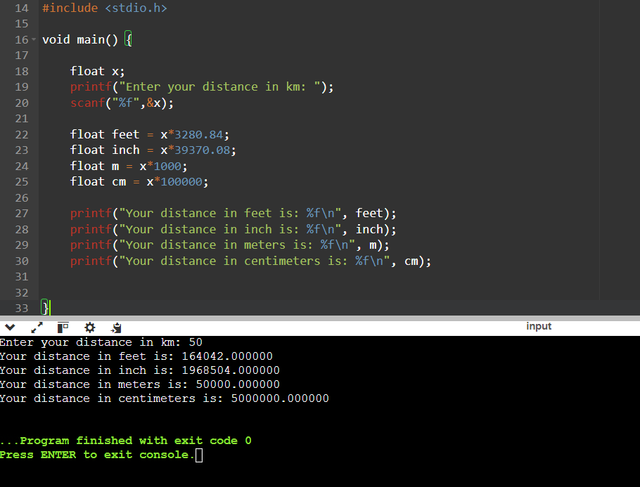

Q-3 Marks Calculator

A student enters his/her marks of 5 subjects in a program.

Assume that the maximum marks that can be obtained by a student in each subject to be 100.

Write a program to calculate the aggregate marks of the student. Also, calculate the percentage

marks obtained by the student.

Code:

#include <stdio.h>

#include <stdlib.h>

void main(){

int x[5];

int sum = 0;

printf("Enter your makrs for 5 subjects: ");

for (int i = 0; i < 5; i++)

{

scanf("%d", &x[i]);

}

for (int i = 0; i < 5; i++)

{

if (x[i] > 100)

{

printf("Invalid marks");

exit(0);

}

else

{

sum = sum + x[i];

}

}

printf("Your total marks are: %d", sum);

float percentage = (sum/500.0)\*100;

printf("\nYour percentage is: %f", percentage);

}

Screenshot:

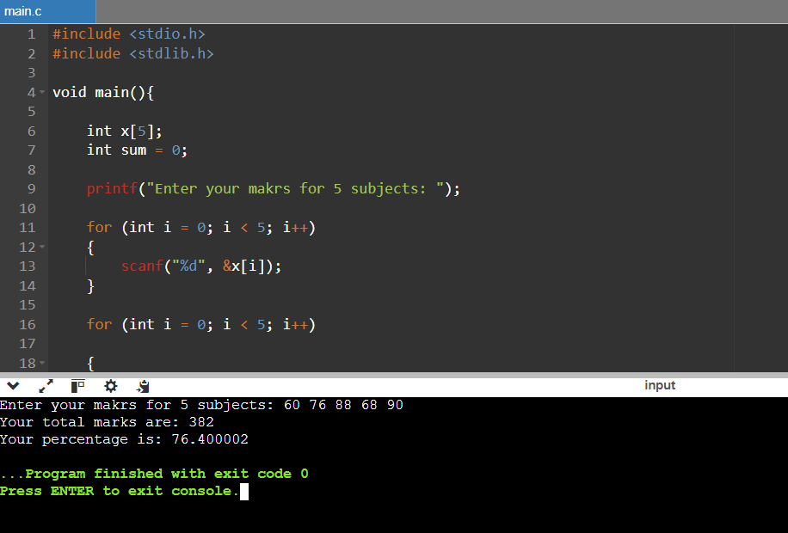

Q-4 Sum of Digits

The user will enter a four-digit number.

Write a program that calculates the sum of its digits. (Hint: Use the modulus operator ‘%’).

Input:

Four-digit number.

Code:

#*include* <stdio.h>

void *main*(){

    int x;

*printf*("Enter a four digit number: ");

*scanf*("%d", &x);

    int a = x/1000;

    int b = (x/100)%10;

    int c = (x/10)%10;

    int d = x%10;

    int sum = a+b+c+d;

*printf*("The sum of the digits is: %d", sum);

}

Screenshot:

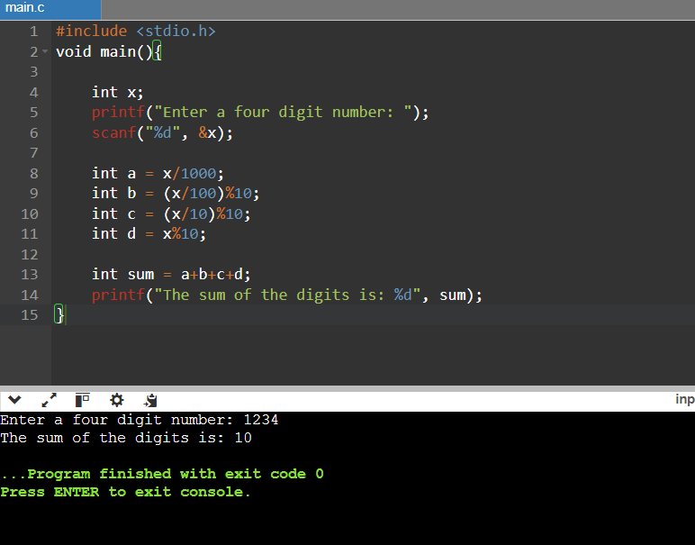

Q-5 Decrementing Digit Problem

Suppose a five-digit number is input by a user.

Write a program to print a new number by subtracting one to each of its digits. For example if

the number that is input is 12391 then the output should be displayed as 01280.

Code:

#include <stdio.h>

void main(){

int x;

printf("Enter a four digit number: ");

scanf("%d", &x);

int y = (x/10000)-1;

int a = ((x/1000)%10)-1;

int b = ((x/100)%10)-1;

int c = ((x/10)%10)-1;

int d = (x%10)-1;

printf("The decremented digits are: %d%d%d%d%d",y,a,b,c,d);

}

Screenshot:

